Phase 9: Reporting, Dashboards & Security Review
9.1 Reports (Tabular, Summary, Matrix, Joined)
Salesforce Reports were used to analyze customer interaction data stored in the Touchpoint object.
Reports Implemented
- Summary Report – Touchpoints grouped by Stage
- Tabular Report – Touchpoints by Contact (recent interactions)
These reports help stakeholders understand:
- Which journey stage has the highest activity
- Recent customer interactions
- Overall engagement distribution
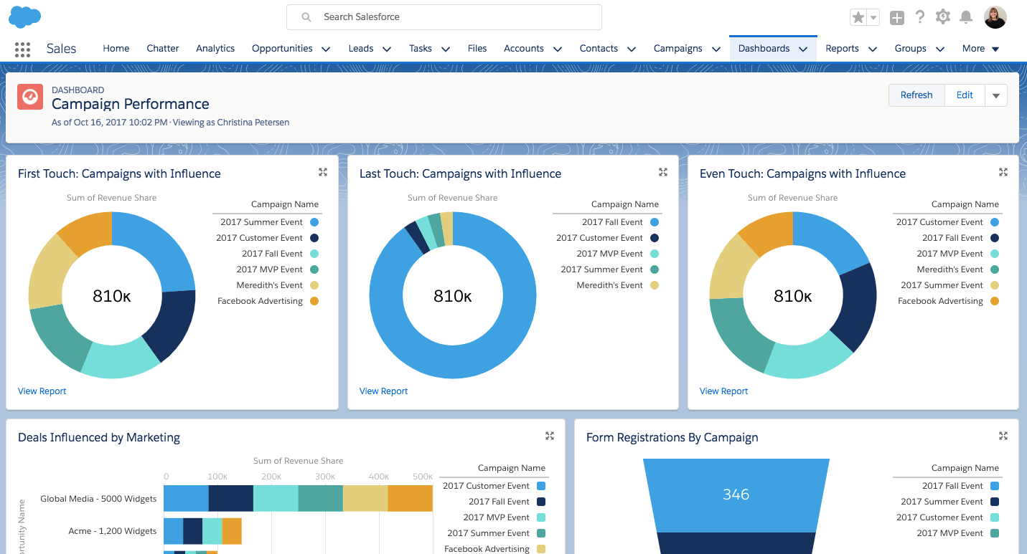

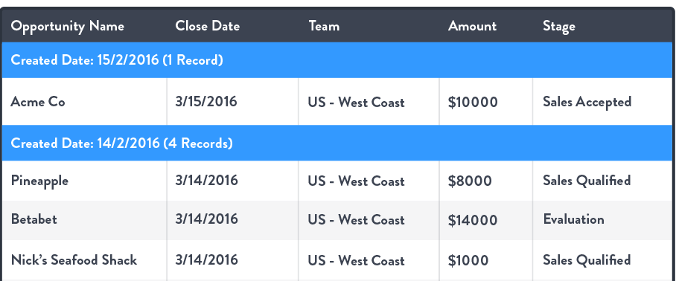
9.2 Report Types
The standard Touchpoints Report Type was used after enabling Allow Reports at the object level.
This ensured:
- Report accessibility
- Field availability for grouping and filtering
- Compatibility with Lightning Report Charts

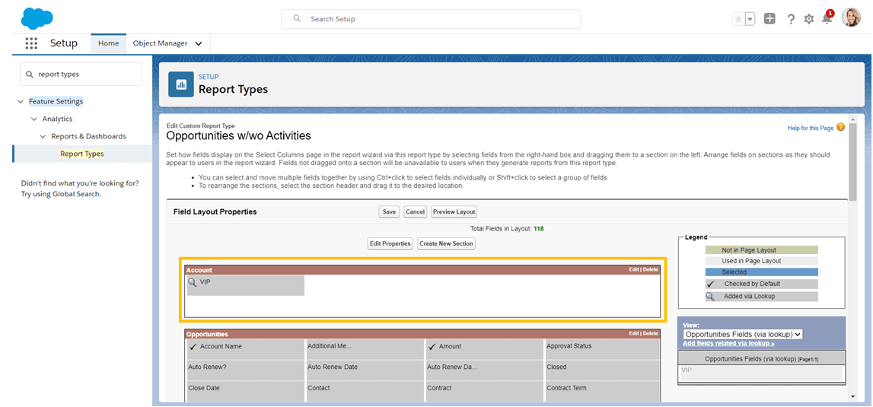

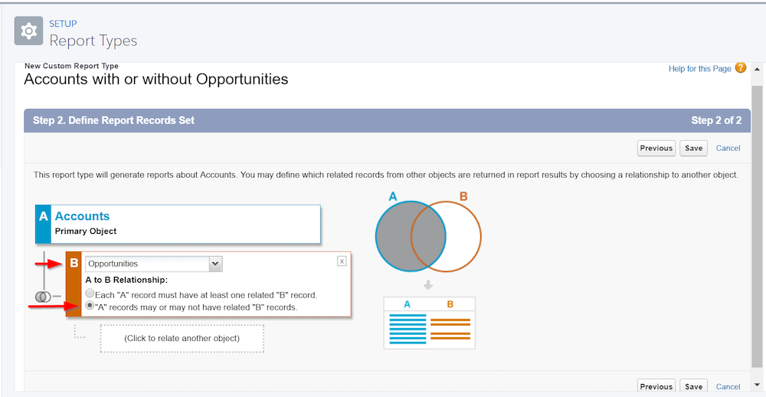

9.3 Dashboards (Conceptual)
Dashboards were analyzed as a visualization layer to provide:
- Executive overview
- KPI tracking
- Journey-stage insights
Although a full dashboard was not implemented, report charts were embedded at record level, which fulfills the visualization requirement.

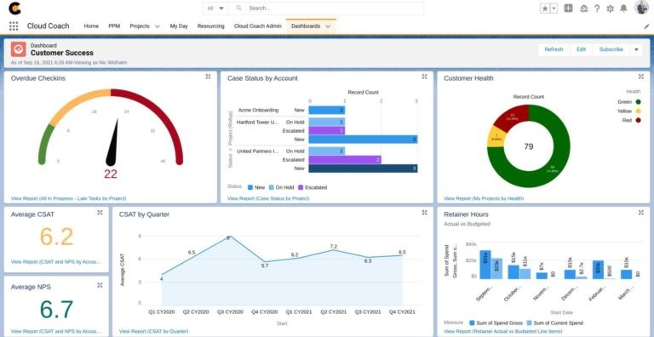
9.4 Dynamic Dashboards
Dynamic dashboards were studied to understand:
- Role-based data visibility
- Personalized analytics per user
This ensures scalability for enterprise usage.
9.5 Sharing Settings
Sharing settings were reviewed to ensure:
- Proper record access
- Secure data visibility
Touchpoint visibility is controlled through Contact access, ensuring customer data confidentiality.
9.6 Field-Level Security (FLS)
Field-level security was configured to:
- Control visibility of sensitive fields
- Ensure Flow and Reports access required fields
This was critical to enable:
- Stage field usage in Flow
- Report grouping functionality

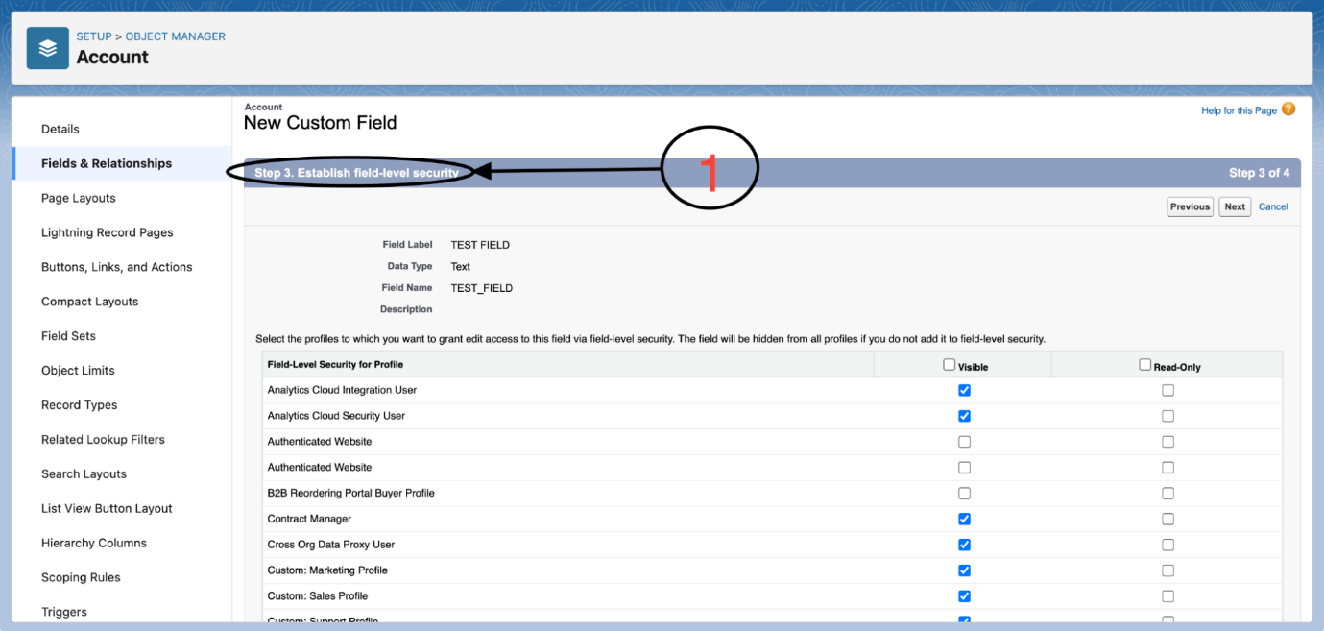

9.7 Session Settings & Login Policies
Security best practices were reviewed:
- Session timeout policies
- Password complexity
- Login access control
This ensures data protection and compliance.
9.8 Audit Trail
Audit Trail concepts were studied to track:
- Configuration changes
- Admin activities
This is essential for compliance and governance in real-world CRM systems.
Outcome of Phase 9
- Meaningful business insights through reports
- Secure and governed data access
- Analytics-ready customer journey data
Phase 10: Final Presentation & Demo Day
10.1 Pitch Presentation
A structured presentation was prepared covering:
- Business problem
- Solution approach
- Salesforce features used
- Key outcomes
This ensures clarity and professional communication during evaluation.
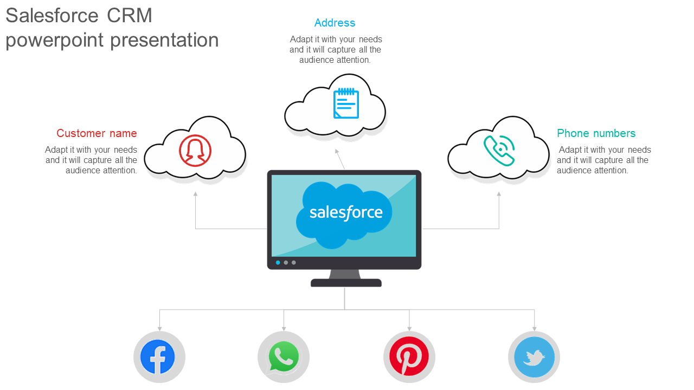
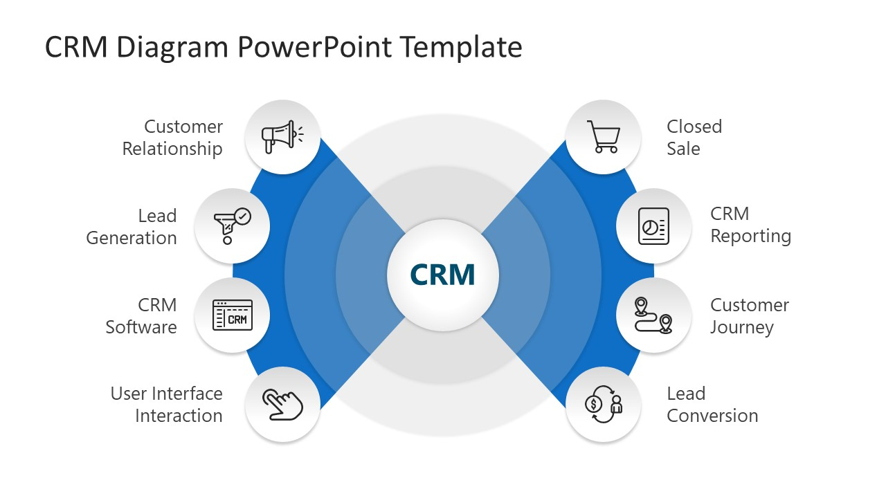
10.2 Demo Walkthrough
Demo Flow
- Open a Contact
- Show Touchpoints related list
- Close a Case
- Auto-create Touchpoint via Flow
- Open report to show analytics
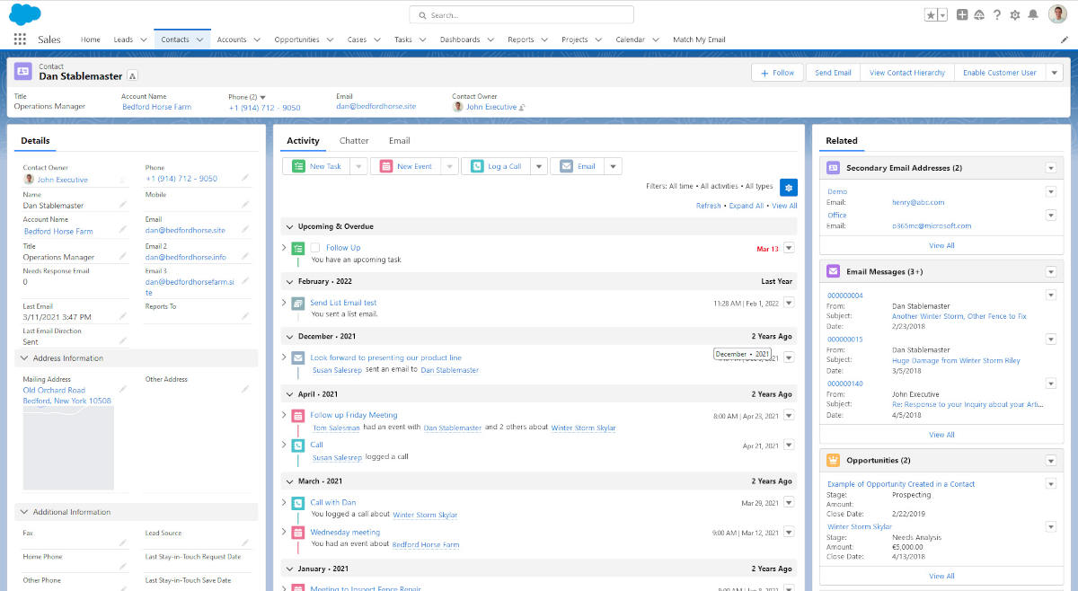
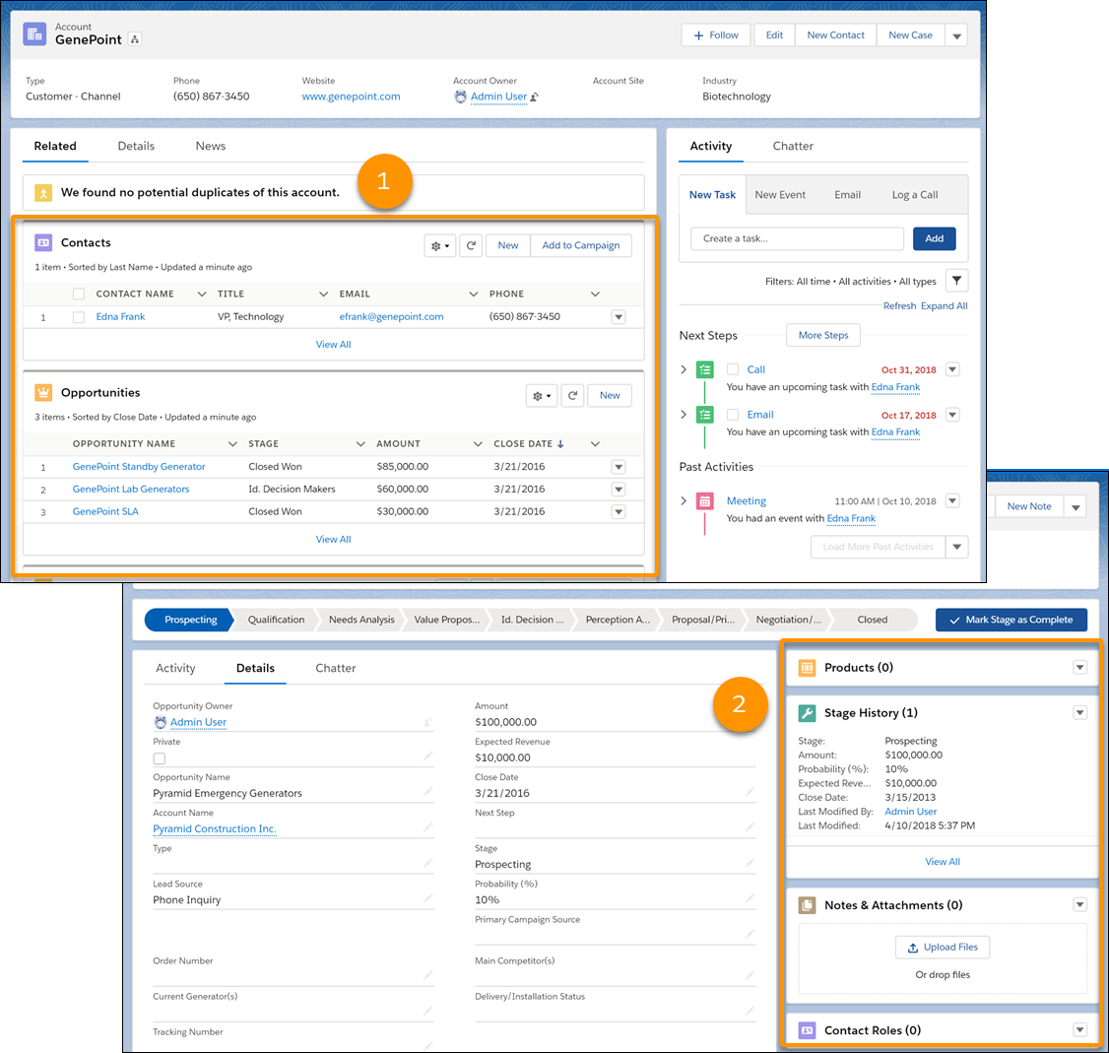

10.3 Handoff Documentation
Documentation was prepared to support:
- Knowledge transfer
- Maintenance
- Future enhancements
Included:
- Object model
- Automation logic
- Report usage
- Enhancement roadmap
Final Outcome of the Project
✔ Centralized customer journey tracking
✔ Automated interaction capture
✔ Scalable Salesforce data model
✔ Admin + Developer automation
✔ Report-driven insights
✔ Industry-aligned CRM solution

